LAB 05 – Part 05_Extended ISA
Group 01—E/20/381 Somathilaka A.N.T
E/20/385 Sriyarathna D.H

01.Instruction Set

Table 01 – mapping between instructions with their corresponding Operational code
Instruction | Opcode
loadi | 0000 0000
mov | 0000 0001
add | 0000 0010
sub | 0000 0011
and | 0000 0100
or | 0000 0101
j | 0000 0110
beq | 0000 0111
bne | 0000 1000
sra | 0000 1001
sla | 0000 1010
srl | 0000 1011
sll | 0000 1100
ror | 0000 1101
rol | 0000 1110
mult | 0000 1111

ALU Functions along with the ALUOP code and it’s delay.

Table 02 – ALU units with their corresponding ALUOP code and their delays
ALU operation | ALUOP code | Delay
forward | 000 | #1
add | 001 | #2
and | 010 | #1
or | 011 | #1
shift | 100 | #1
rotation | 101 | #1
multiplication | 110 | #3

02. Control Unit Signals
Table 03 – mapping between instruction opcodes and their decoded signals
Instruction | opcode | write-  enable | istwo-  comp | isreg-  out | ALUop | beq | jump | bne | islogicalorisleft
loadi | 0000 0000 | 1 | 0 | 0 | 000 | 0 | 0 | 0 | 00
mov | 0000 0001 | 1 | 0 | 1 | 000 | 0 | 0 | 0 | 00
add | 0000 0010 | 1 | 0 | 1 | 001 | 0 | 0 | 0 | 00
sub | 0000 0011 | 1 | 1 | 1 | 001 | 0 | 0 | 0 | 00
and | 0000 0100 | 1 | 0 | 1 | 010 | 0 | 0 | 0 | 00
or | 0000 0101 | 1 | 0 | 1 | 011 | 0 | 0 | 0 | 00
j | 0000 0110 | 0 | 0 | 0 | 000 | 0 | 1 | 0 | 00
beq | 0000 0111 | 0 | 1 | 1 | 001 | 1 | 0 | 0 | 00
bne | 0000 1000 | 0 | 1 | 0 | 001 | 0 | 0 | 1 | 00
sra | 0000 1001 | 1 | 0 | 0 | 100 | 0 | 0 | 0 | 00
sla | 0000 1010 | 1 | 0 | 0 | 100 | 0 | 0 | 0 | 01.
srl | 0000 1011 | 1 | 0 | 0 | 100 | 0 | 0 | 0 | 10
sll | 0000 1100 | 1 | 0 | 0 | 100 | 0 | 0 | 0 | 11
ror | 0000 1101 | 1 | 0 | 0 | 101 | 0 | 0 | 0 | 00
rol | 0000 1110 | 1 | 0 | 0 | 101 | 0 | 0 | 0 | 01
mult | 0000 1111 | 1 | 0 | 1 | 110 | 0 | 0 | 0 | 00
In above,
- writeenable: Write Enable signal sent to the Register File to enable writing to a register.
- istwoscomp: Selects the twos complement from the register output to perform subtraction.
- isregout: Selects between the immediate value and the register out 2.
- ALUop: ALU Operation Code sent to the ALU.
- beq: Selects the target address to override the PC to execute a branch if equal instruction.
- jump: Select the target address to override the PC to execute a jump instruction.
- bne: Select the target address to override the PC to execute a branch if NOT equal instruction.
- islogicalorisleft: Selects between shifting right and shifting left, this is done by reversing the order of the 8-bit value from the register output.
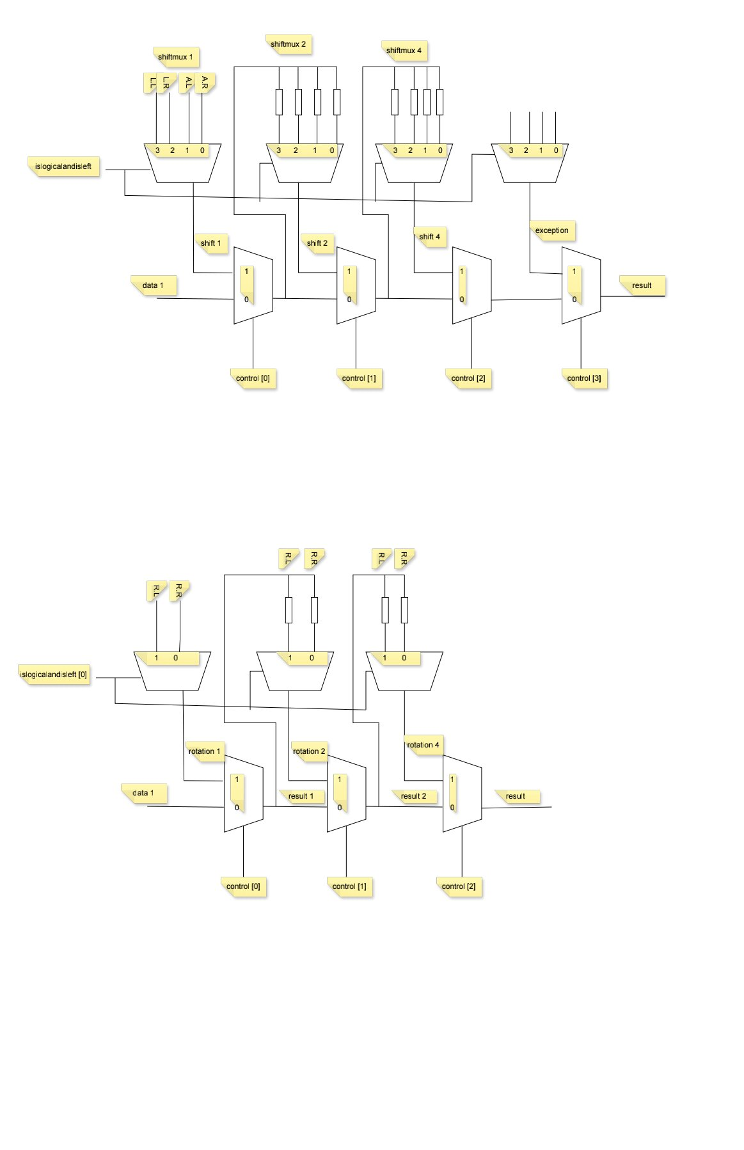
03.Shift Unit
Figure 1.0 – hardware design for shift Unit

All shifting functionalities were implemented in a single shift unit. Therefore the timing diagram for all shifting functionalities (arithmetic right shift, arithmetic left shift, logical right shift, logical left shift) as follows.
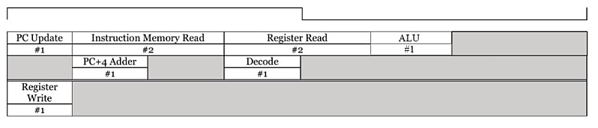
Figure 1.1 – timing diagram for the all shifting functionalities

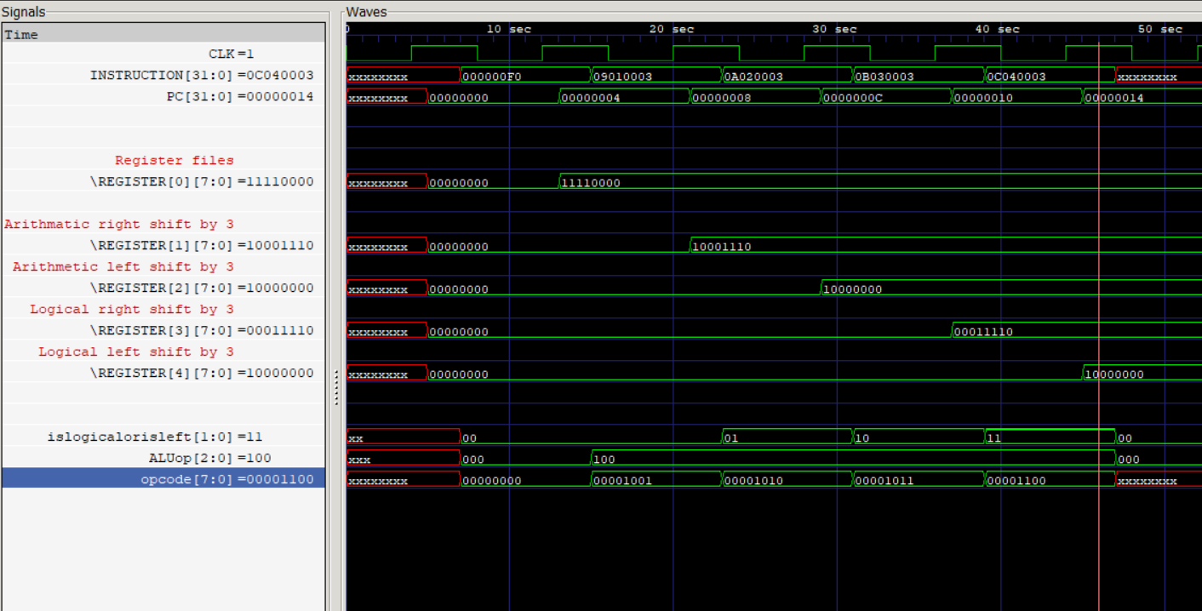
Figure 1.2 – GTKwave file of shift unit functions

04.Rotate Right and Rotate Left Instructions
Figure 2.0 – Hardware implementation of the rotation unit
Due to the lack of ALUOP in the hardware design we used cascade muxes to implement both the right rotation and left rotation.
Therefore both rotations had the same time delay as shown in figure 2.1.
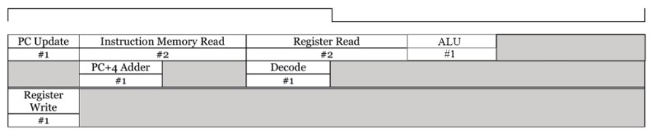
Figure 2.1 – timing diagram for the rotation unit

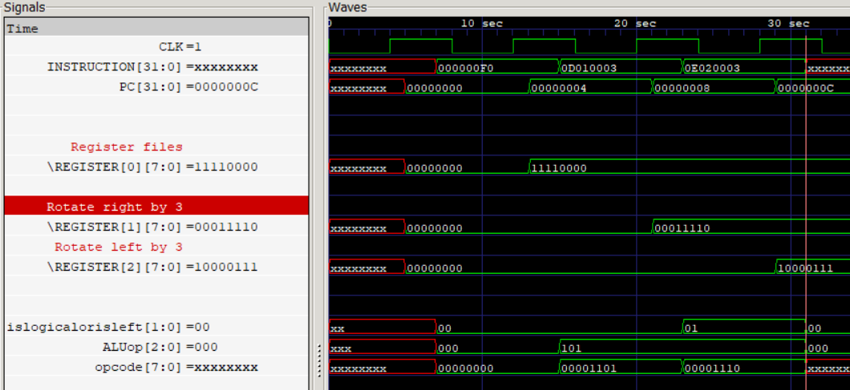
Figure 2.2 – GTKwave file of rotation unit functions

05.Multiplication Instructions

When doing multiplication we used bitwise AND, logical shifting, and full adder to obtain the desired output the arithmetic functionalities are shown below example.
Example:
Assume we need to multiply 3 and 5.
0000 0101

0000 0011
0000 0011
0000 0011
0000 0000
0000 0000
15
0000 1111
0000 0000

So we get one bit at a time of one number and do AND logic function with other numbers to all 8bits respectively. After that we left shift the result the first one by 1 and left shift the second result by 2 up to the last result respectively. After that, we add the shift results to obtain the final result.
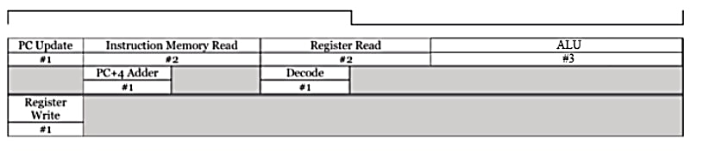
Figure 3.1 – timing diagram of the multiplication

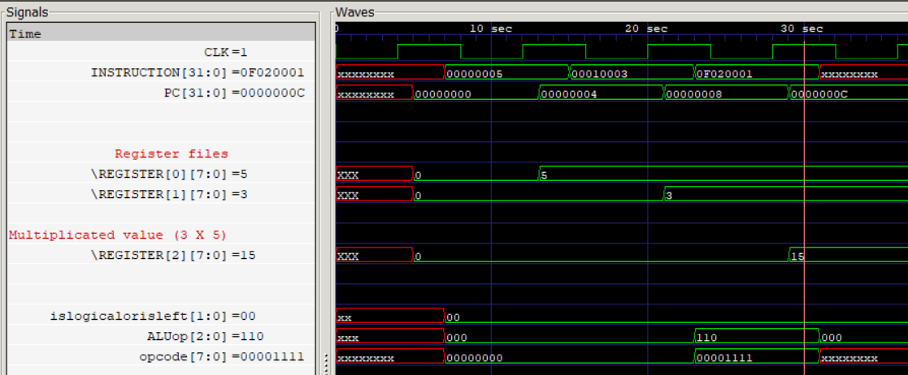
Figure 3.2 – GTKwave of the multiplication

06. Branch not Equal
An additional control signal was generated from the control unit (bne). If bne is “1” and “zero” is not equal to 0, then the PC will be written the target address instead of PC+4.
For an example let’s consider below assembly code
loadi 0 0x05
loadi 1 0x03
bne 0 1 0x01
loadi 2 0x01
mult 2 0 1

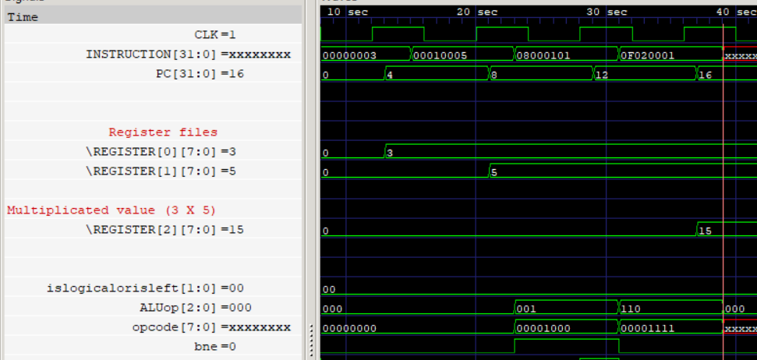
Figure 4.1 – GTKwave belong to above assembly code

